Telangana State Industrial Project Approval & Self Certification System (TS-iPASS)

IPO / AD Login Incentive Module
USER MANUAL

Login Screen:

Login Screen
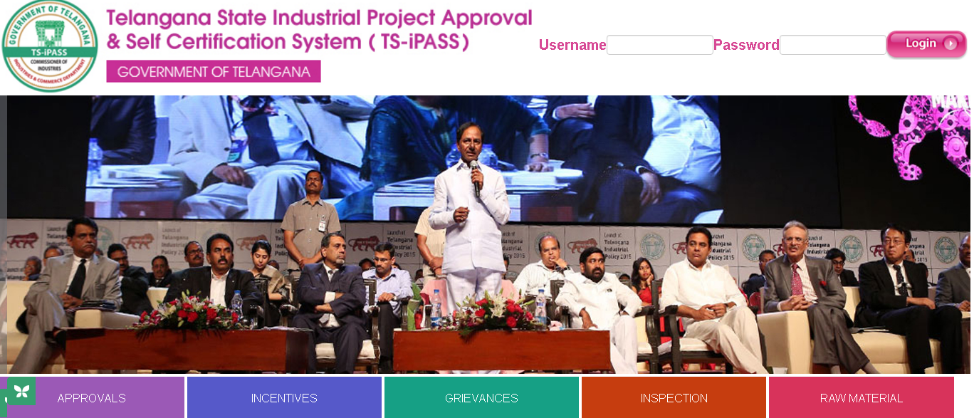
Screen Description:

This screen is used to Authenticate and Authorize for accessing and using different features and functionalities in Telanagana State Industrial Project Approval & Self Certification System (TS-iPASS). You can Login to the application by providing your User Credentials like User Name and Password.
Sl. No | Input Type | Description | Mandatory (Yes/No/NA)
1 | User Name | Enter the User name | Yes
2 | Password | Enter the Password | Yes
3 | Login | Click on Login button to log into the MIS | Yes
4 | Cancel | Click on Cancel to clear the columns in the Login Page | NA

Work flow of IPO / AD in Incentive Module:

Receiving of concerned incentive applications from DIC

Scheduling inspection date in the MIS

Uploading the Inspection report after completion of Inspection

Forwarding the inspection report uploaded applications to DIC for further process.

Incentives Menu
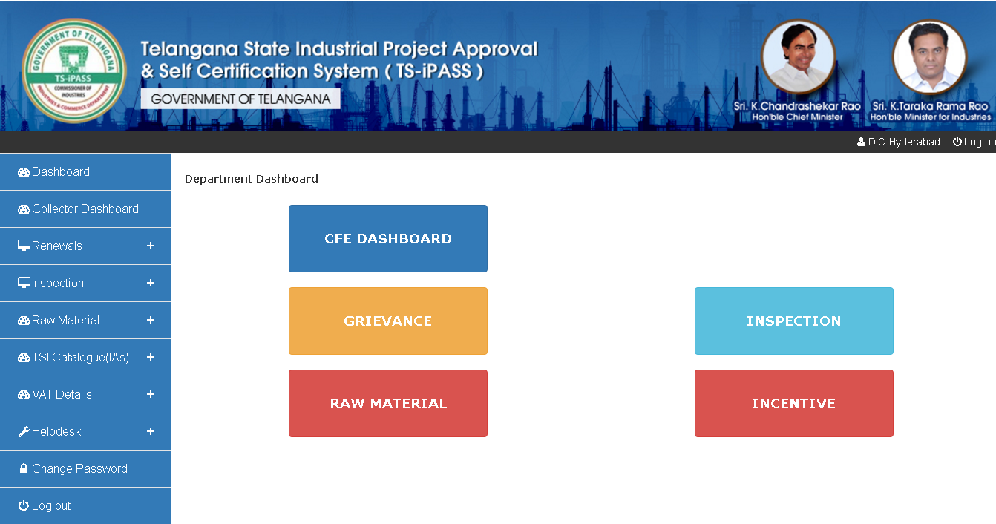
Screen Description: When you click on Incentives under Dashboard below screen will be displayed.

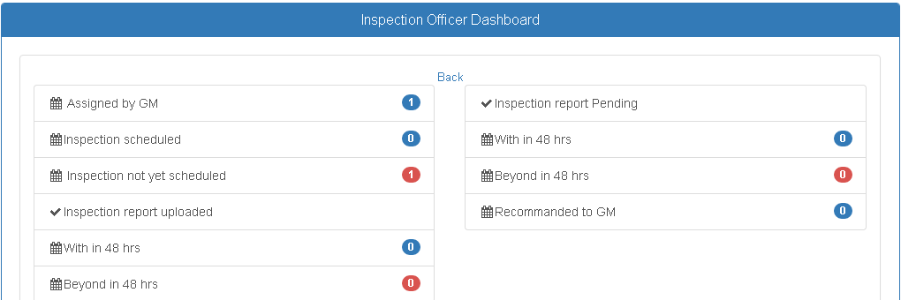
Applications forwarded by DICs will be displayed under Assigned by GM option above. You can schedule inspection date for the inspection application by clicking on Inspection not yet scheduled. When you click on Inspection not yet scheduled below screen will be displayed:

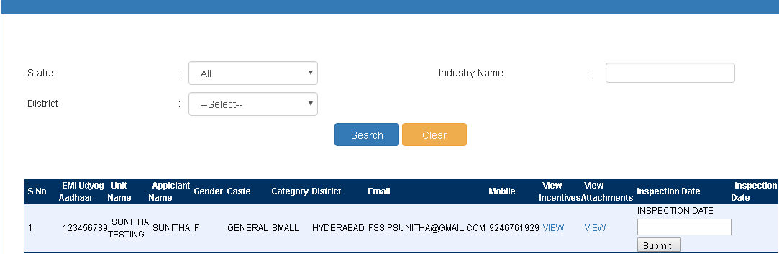
In the above screen enter the Inspection date when IPO / AD is scheduing for an inspection. Enter the inspection date and click on submit button for saving the details. Inspection to be done within 48 hours of the date of application received. Once you shedule the inspection message & email alert will be sent to the entreprenuer as regards the inspection. IPO / AD need to click on Inspection Report pending for uploading the inspection report:

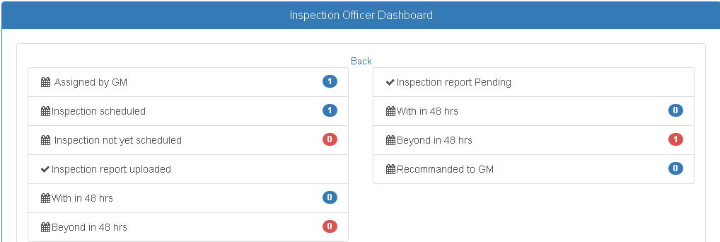
When you select the appropriate option from the dashboard below screen will be displayed to upload the inspection report:

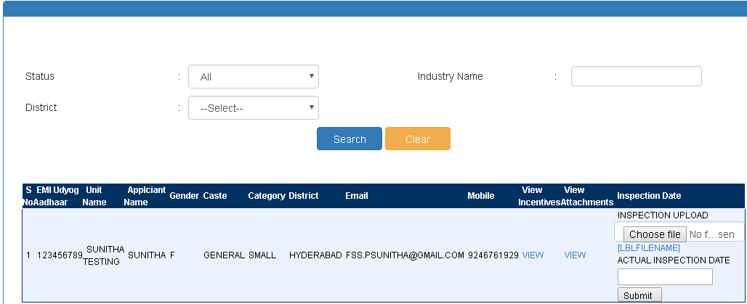
In the above screen upload the inspection document, enter the actual insepction dat and click on Submit button. Then the uploaded inspection report will be forwarded to DIC for further process.

****** Thank You ******

